FAQs for Teens in MyCooper
Privacy Notice:
The information Cooper provides in your MyCooper account is private information. Under NJ law, you do not have to share this information with your parents, unless you choose to do so. Please contact Cooper's privacy officer by calling 856.361.1967 or e-mailing privacyofficer@cooperhealth.edu should you or your parents have any questions.

Q: What is MyCooper?
A: MyCooper offers patients personalized and secure on-line access to portions of their medical records. It enables you to securely use the internet to help manage and receive information about your health. With MyCooper, you can:

•Communicate electronically and securely with your medical care team.
•Request prescription renewals.
•Request medical appointments.
•View test results.
•View your health summary from the MyCooper electronic health record.

Q: How do I get a MyCooper account?
A: Teen patients between the ages of 12 and 18 years of age may request a MyCooper account. During your visit, the office staff can activate your account or send you an email with an activation code.

Q: Can I access myCooper from my smartphone?
A: Yes, MyCooper is available through an application on smart phones. To get the smart phone application, visit your app store. There is a link on the welcome screen to the Apple App Store and Google Play.

Q: What should I do when I first log into MyCooper?
A: First, carefully review the terms and conditions. Go to the Settings tab and check your email address located under Notifications. This is the address where you will receive alerts about new messages, test results and upcoming appointments; it is your responsibility to make sure you choose an email address where your privacy is ensured.
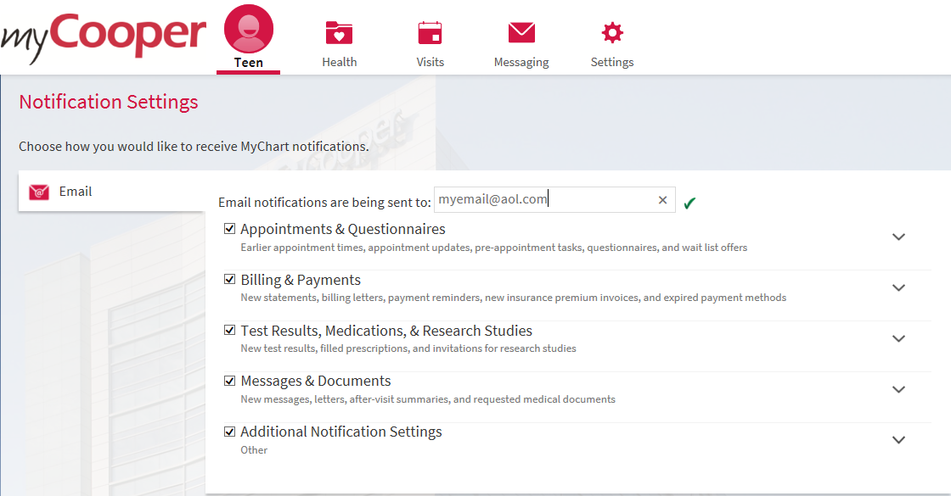

Q: Who can see my messages?
A: Your teen MyCooper account is set up so that any parents or guardians who have proxy access will automatically see all of your messages and appointment requests. It is up to you to remove their ability to see them, and you must do so every time that you send a message or appointment request.
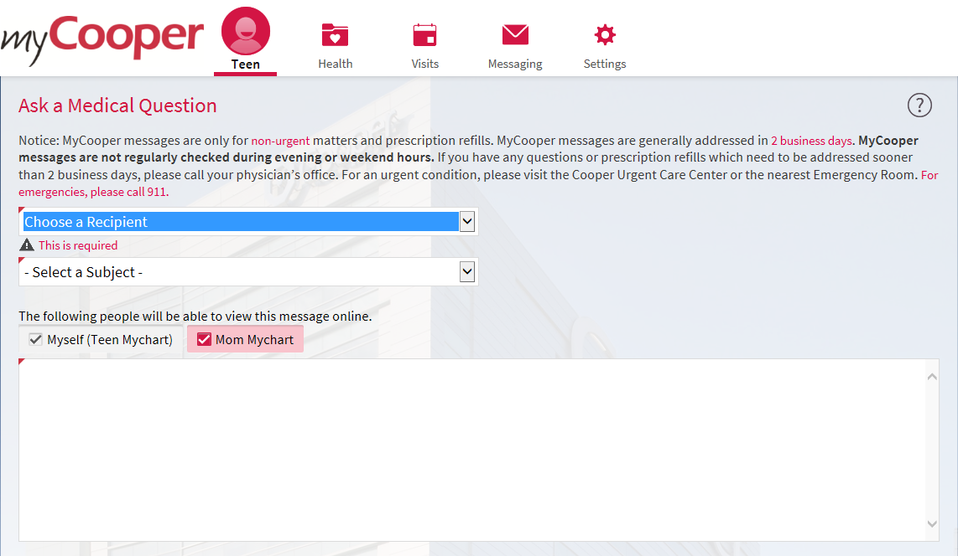
To remove their access, uncheck the box with the proxy’s name before sending the message.
• If you do not uncheck the box shown above before sending, your parent or guardian with proxy access can see your message or request. They may also be notified by email that you sent a message to your care team.
• If you do uncheck the box before sending, your parent or guardian will not see the message or be notified.
Q: What if my parent or guardian already has proxy access to my medical information?
A: Once you turn 12 years old, your proxy’s access to your medical information is automatically restricted; a proxy can view your immunizations and send a message to your doctor’s office. A proxy will also be able to view messages unless you remove their access.

Q: Can I revoke my proxy’s access?
A: Yes, from the Settings tab, under personalize, you will find a revoke button.

Q: What if I need help?
A: The MyCooper support desk can provide assistance 24/7/365 by calling 1.844.3.myCooper (1-844-369-2667) or you may contact us by email at MyCooperSupport@cooperhealth.edu -- please include your name and date of birth in the communication.

